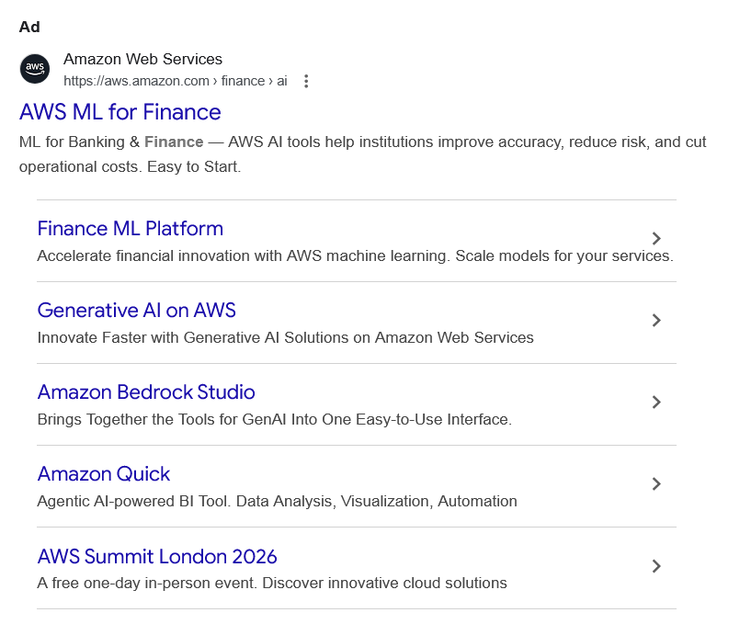
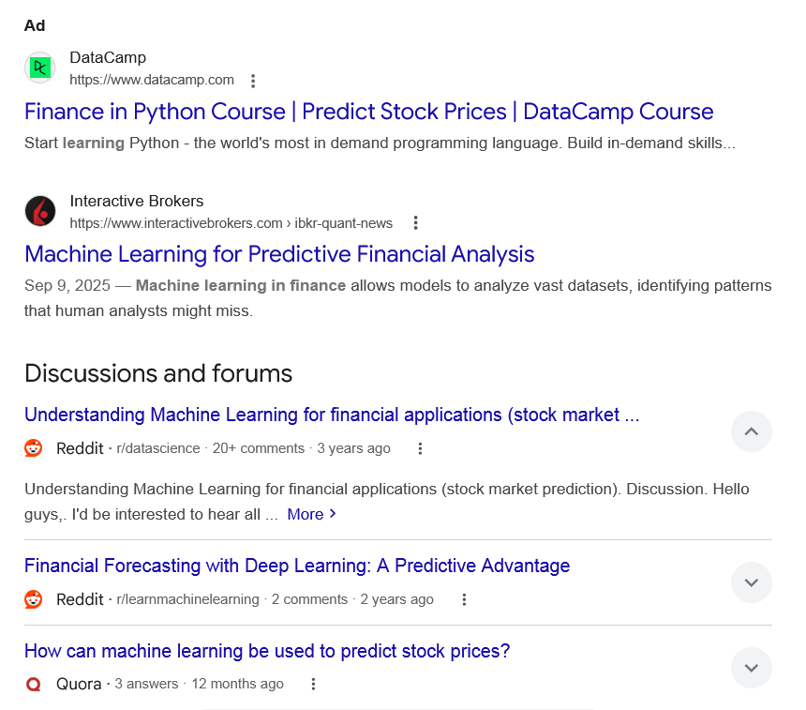
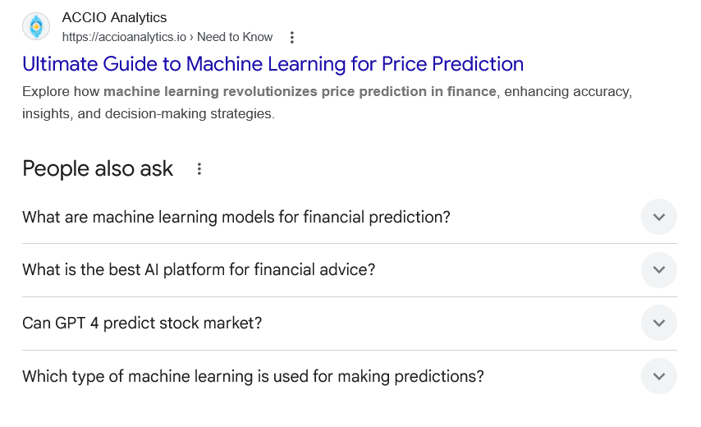
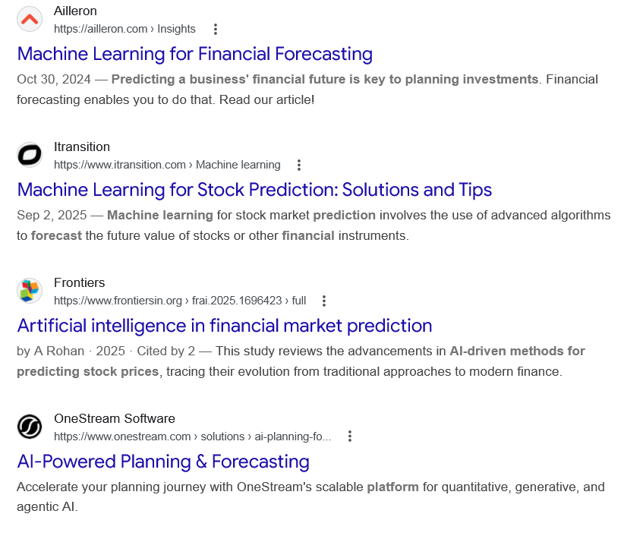
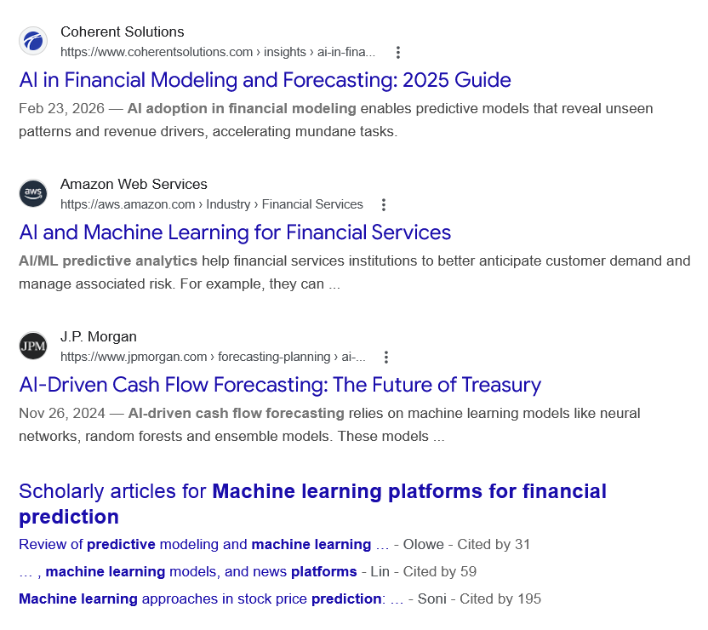
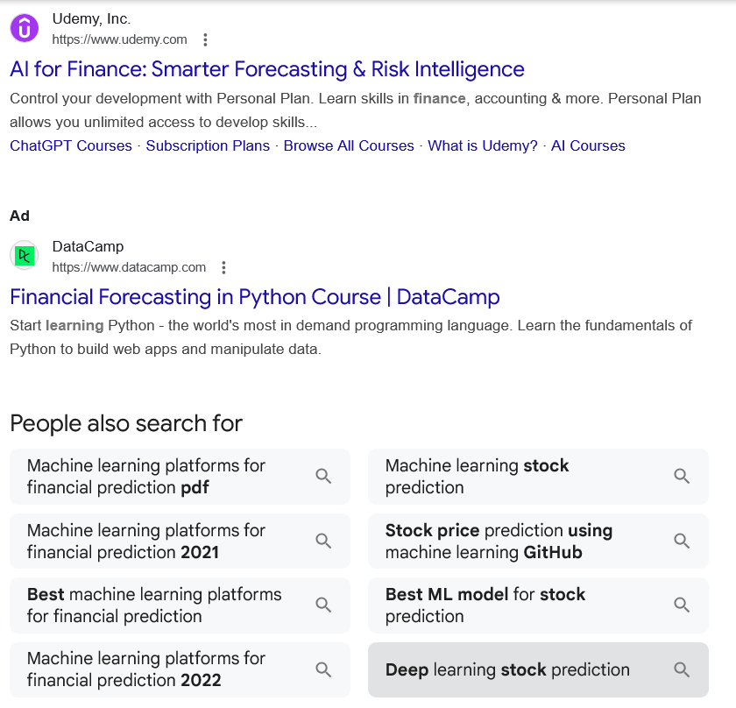

Ad

AWS ML for Finance
Amazon Web Services
https://aws.amazon.com › finance › ai

Amazon Web Services
https://aws.amazon.com › finance › ai

My Ad Centre
ML for Banking & Finance — AWS AI tools help institutions improve accuracy, reduce risk, and cut operational costs. Easy to Start.

Finance ML Platform
Accelerate financial innovation with AWS machine learning. Scale models for your services.

Generative AI on AWS
Innovate Faster with Generative AI Solutions on Amazon Web Services

Amazon Bedrock Studio
Brings Together the Tools for GenAI Into One Easy-to-Use Interface.

Amazon Quick
Agentic AI-powered BI Tool. Data Analysis, Visualization, Automation

AWS Summit London 2026
A free one-day in-person event. Discover innovative cloud solutions

People also search for
Ad

Finance in Python Course | Predict Stock Prices | DataCamp Course
DataCamp
https://www.datacamp.com

DataCamp
https://www.datacamp.com

My Ad Centre
Start learning Python - the world's most in demand programming language. Build in-demand skills...

People also search for

Web results

Machine Learning for Predictive Financial Analysis

Interactive Brokers
https://www.interactivebrokers.com › ibkr-quant-news

Interactive Brokers
https://www.interactivebrokers.com › ibkr-quant-news
Sep 9, 2025 — Machine learning in finance allows models to analyze vast datasets, identifying patterns that human analysts might miss.
Discussions and forums

Understanding Machine Learning for financial applications (stock market ...
Reddit ·
r/datascience
· 20+ comments
· 3 years ago

Understanding Machine Learning for financial applications (stock market ...
Reddit ·
r/datascience
· 20+ comments
· 3 years ago
Understanding Machine Learning for financial applications (stock market prediction). Discussion. Hello guys,. I'd be interested to hear all ... More

Financial Forecasting with Deep Learning: A Predictive Advantage
Reddit ·
r/learnmachinelearning
· 2 comments
· 2 years ago

Financial Forecasting with Deep Learning: A Predictive Advantage
Reddit ·
r/learnmachinelearning
· 2 comments
· 2 years ago
Learning about AI for financial analysts. 5. 15 ; Stock market volatility forecasting using AI. 1. 0 ; About Machine Learning and Why It's Not ... More

How can machine learning be used to predict stock prices?
Quora ·
3 answers
· 12 months ago

How can machine learning be used to predict stock prices?
Quora ·
3 answers
· 12 months ago
I will go against what everyone else is saying and tell you than no, it cannot do it reliably. ... More
Top answer · 140 votes · 8 years ago
Most data scientist / data analysts have probably wanted to dig into this topic at some point. ... More
108 votes · 8 years ago
AI Strategies Outperform Human Traders It is difficult to find performance data for AI strategies ... More
48 votes · 8 years ago

See more

Web results

Ultimate Guide to Machine Learning for Price Prediction

ACCIO Analytics
https://accioanalytics.io › Need to Know

ACCIO Analytics
https://accioanalytics.io › Need to Know
Explore how machine learning revolutionizes price prediction in finance, enhancing accuracy, insights, and decision-making strategies.
People also ask
What are machine learning models for financial prediction?
Machine learning in finance allows models to analyze vast datasets, identifying patterns that human analysts might miss. These models can recognize trends, forecast market movements, and even predict potential financial crises.Sep 9, 2025

Machine Learning for Predictive Financial Analysis

Interactive Brokers
https://www.interactivebrokers.com › ibkr-quant-news

Interactive Brokers
https://www.interactivebrokers.com › ibkr-quant-news
What is the best AI platform for financial advice?
CNBC Select previously recommended Betterment and Monarch for their automated investing and budgeting tools. We also like Cleo for its AI chatbot, which provides spending insights and money management advice.Feb 4, 2026

AI-powered tools offer help with your financial planning — should you bite?

CNBC
https://www.cnbc.com › select › ai-powered-financial-pla...

CNBC
https://www.cnbc.com › select › ai-powered-financial-pla...
Can GPT 4 predict stock market?
Short term: RoBERTa model leads the forecasting but with little margin over the rest. Medium term: GPT-4 tends to outperform the rest of models in flat markets, in case of bigger price movements, RoBERTa model is more precise.

Predicting stock price trends using language models to extract the ...

ScienceDirect.com
https://www.sciencedirect.com › science › article › pii

ScienceDirect.com
https://www.sciencedirect.com › science › article › pii
Which type of machine learning is used for making predictions?
Supervised learning
Supervised learning uses labeled data to train models that predict outcomes for new, unseen data. The training process involves feeding the model labeled examples, allowing it to learn the relationship between features and labels.Aug 25, 2025

Supervised Learning | Machine Learning - Google for Developers

Google for Developers
https://developers.google.com › intro-to-ml › supervised

Google for Developers
https://developers.google.com › intro-to-ml › supervised

Web results

Machine Learning for Financial Forecasting

Ailleron
https://ailleron.com › Insights

Ailleron
https://ailleron.com › Insights
Oct 30, 2024 — Predicting a business' financial future is key to planning investments. Financial forecasting enables you to do that. Read our article!

Machine Learning for Stock Prediction: Solutions and Tips

Itransition
https://www.itransition.com › Machine learning

Itransition
https://www.itransition.com › Machine learning
Sep 2, 2025 — Machine learning for stock market prediction involves the use of advanced algorithms to forecast the future value of stocks or other financial instruments.

Artificial intelligence in financial market prediction

Frontiers
https://www.frontiersin.org › frai.2025.1696423 › full

Frontiers
https://www.frontiersin.org › frai.2025.1696423 › full
by A Rohan · 2025 · Cited by 2 — This study reviews the advancements in AI-driven methods for predicting stock prices, tracing their evolution from traditional approaches to modern finance.

AI-Powered Planning & Forecasting

OneStream Software
https://www.onestream.com › solutions › ai-planning-fo...

OneStream Software
https://www.onestream.com › solutions › ai-planning-fo...
Accelerate your planning journey with OneStream's scalable platform for quantitative, generative, and agentic AI.

AI in Financial Modeling and Forecasting: 2025 Guide

Coherent Solutions
https://www.coherentsolutions.com › insights › ai-in-fina...

Coherent Solutions
https://www.coherentsolutions.com › insights › ai-in-fina...
Feb 23, 2026 — AI adoption in financial modeling enables predictive models that reveal unseen patterns and revenue drivers, accelerating mundane tasks.

AI and Machine Learning for Financial Services

Amazon Web Services
https://aws.amazon.com › Industry › Financial Services

Amazon Web Services
https://aws.amazon.com › Industry › Financial Services
AI/ML predictive analytics help financial services institutions to better anticipate customer demand and manage associated risk. For example, they can ...

AI-Driven Cash Flow Forecasting: The Future of Treasury

J.P. Morgan
https://www.jpmorgan.com › forecasting-planning › ai-...

J.P. Morgan
https://www.jpmorgan.com › forecasting-planning › ai-...
Nov 26, 2024 — AI-driven cash flow forecasting relies on machine learning models like neural networks, random forests and ensemble models. These models ...

Scholarly articles for Machine learning platforms for financial prediction
Review of predictive modeling and machine learning … - ‎Olowe - Cited by 31
… , machine learning models, and news platforms - ‎Lin - Cited by 59
Machine learning approaches in stock price prediction: … - ‎Soni - Cited by 195
Ad

AI for Finance: Smarter Forecasting & Risk Intelligence

Udemy, Inc.
https://www.udemy.com

Udemy, Inc.
https://www.udemy.com

My Ad Centre
Control your development with Personal Plan. Learn skills in finance, accounting & more. Personal Plan allows you unlimited access to develop skills...
‎ChatGPT Courses · ‎Subscription Plans · ‎Browse All Courses · ‎What is Udemy? · ‎AI Courses
Ad

Financial Forecasting in Python Course | DataCamp
DataCamp
https://www.datacamp.com

DataCamp
https://www.datacamp.com

My Ad Centre
Start learning Python - the world's most in demand programming language. Learn the fundamentals of Python to build web apps and manipulate data.
People also search for

Machine learning platforms for financial prediction pdf

Machine learning platforms for financial prediction 2021

Best machine learning platforms for financial prediction

Machine learning platforms for financial prediction 2022

Machine learning stock prediction

Stock price prediction using machine learning GitHub

Best ML model for stock prediction

Deep learning stock prediction

Page navigation
 | 1 | 2 | 3 | 4 | 5 | 6 | 7 | 8 | 9 | 10 | Next

